SIMATS ENGINEERING
ASSESSMENT TOOL 3

COURSE NAME: Artificial Intelligence COURSE CODE: CSA17

COURSE OUTCOME COVERED
CO2: Experiment search and game-solving techniques such as Greedy Search, A*, CSP, Minimax, and Alpha-Beta pruning with heuristic functions for solving complex AI problems efficiently. (BL3)
Assessment Tool Weightage: 40%

Duration: 1 Hour
QUESTIONS: 3 Total Marks:30
Annexure A
Dry Run Evaluation

Code of Conduct:
I MONIKA.B (192571002) certify that this submission is my original work and that I have adhered to the guidelines specified for this assessment.
I understand that any violation of academic integrity rules will result in disciplinary action.
Signature of the student:

MONIKA.B

Annexure A
Dry Run Evaluation

1. Question 1 – Breadth-First Search (BFS) Consider the following graph: A
/ \

B C

/ \ / \

D E F G

Task: Starting from node A, perform a Breadth-First Search (BFS). Complete the following table.

Iteration Queue Visited Node
1
2
3
4
5
6
7

Questions:

- Write the BFS traversal order.
- Show the queue contents after each iteration.

2. Depth-First Search (DFS) Using the same graph,
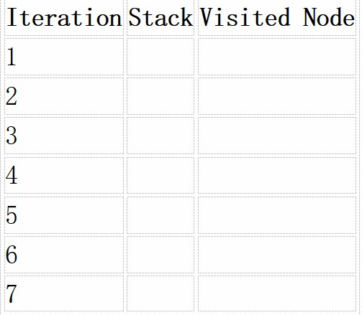
A
/ \
B C
/ \ / \
D E F G

Perform Depth-First Search (DFS) starting from A.
Complete the table.
3. Initial State :
1 3 6
5 0 2
4 7 8

Goal State :
1 2 3
4 5 6
7 8 0

Task

Trace Breadth-First Search (BFS) until the goal state is reached.
Fill in the table.
Iteration Current State Queue Before Expansion Queue After Expansion
1
2
3
4
5

Questions

- Which node is expanded in each iteration?
- How many states are generated in total?
- Write the complete solution path from the initial state to the goal state.
- Why does BFS always find the shortest solution in an unweighted 8-puzzle problem?
RUBRICS FOR CALCULATION

Criteria | Weightage (%) | Level 4 –  Exemplary (4) | Level 3 –  Proficient (3) | Level 2 –  Developing (2) | Level 1 –  Beginning (1)
Understandi ng of Search Problem | 20 | Clearly understands the search problem, initial state, goal state, and search strategy. | Understands the problem with minor misunderstandi ngs. | Demonstrates  partial understanding of the search problem. | Shows little or no understanding of the search problem.
State  Expansion and Dry Run  Execution | 30 | Correctly traces every iteration, expands nodes accurately, and maintains the  Queue/Stack/Priority Queue without errors. | Performs most iterations correctly with  minor mistakes in state expansion or data structure updates. | Performs only some iterations correctly; several errors in tracing or node expansion. | Unable to correctly perform the dry run or expand states.
Application of Search Algorithm | 20 | Applies the selected algorithm  (BFS/DFS/UCS)  correctly, following all algorithmic rules. | Applies the algorithm correctly with a few procedural errors. | Applies only basic algorithm steps with noticeable mistakes. | Fails to apply the correct search algorithm.
Accuracy of  Solution  Path | 20 | Identifies the correct traversal order/solution path and goal state with proper justification. | Solution path is mostly correct with minor errors. | Partially correct solution path; goal may not be reached correctly. | Incorrect or incomplete solution path.
Presentation and Logical Reasoning | 10 | Queue/Stack/Priority Queue updates, state diagrams, and explanations are neat, organized, and logically presented. | Presentation is clear with minor organizational issues. | Limited explanation and organization; reasoning is partially clear. | Poor presentation with unclear or missing reasoning.

Question 1 — Breadth-First Search (BFS)
Graph: A → B, C | B → D, E | C → F, G

Code
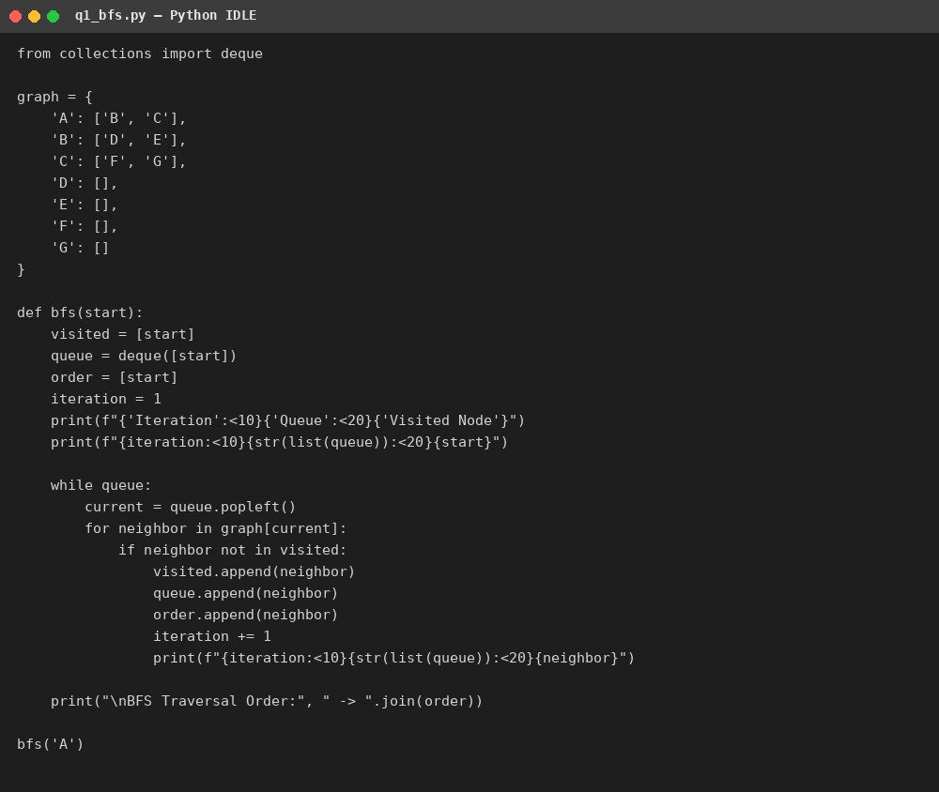

Output
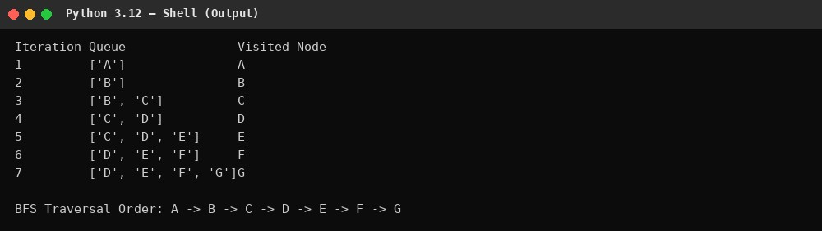
BFS Traversal Order: A → B → C → D → E → F → G

Question 2 — Depth-First Search (DFS)
Code
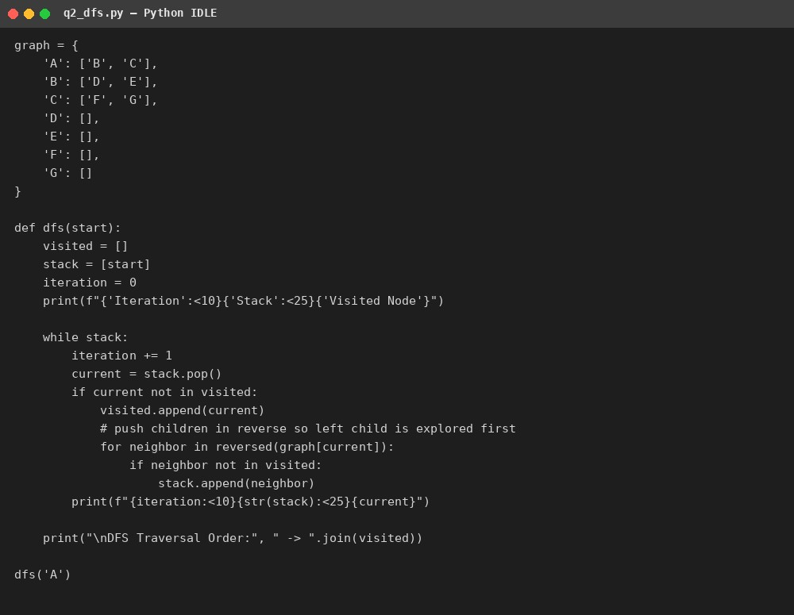

Output
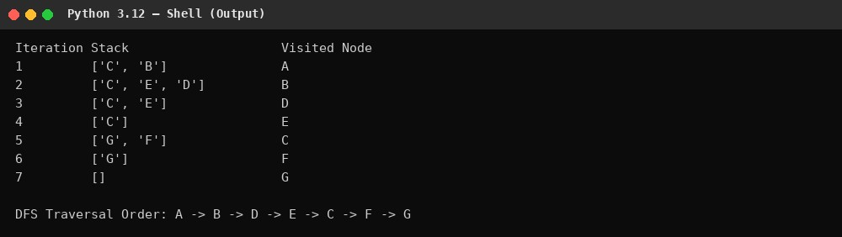

DFS Traversal Order: A → B → D → E → C → F → G

Question 3 — 8-Puzzle solved with Breadth-First Search

Code
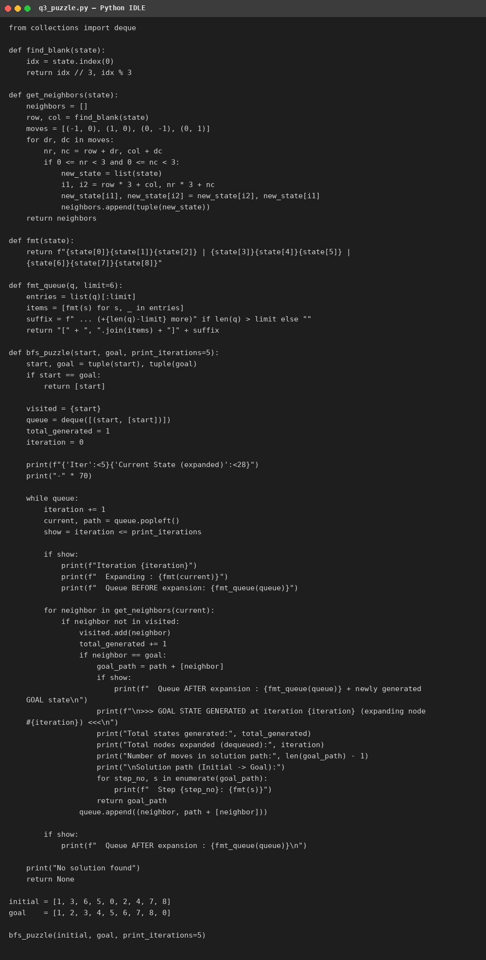

q3_puzzle.py

Output
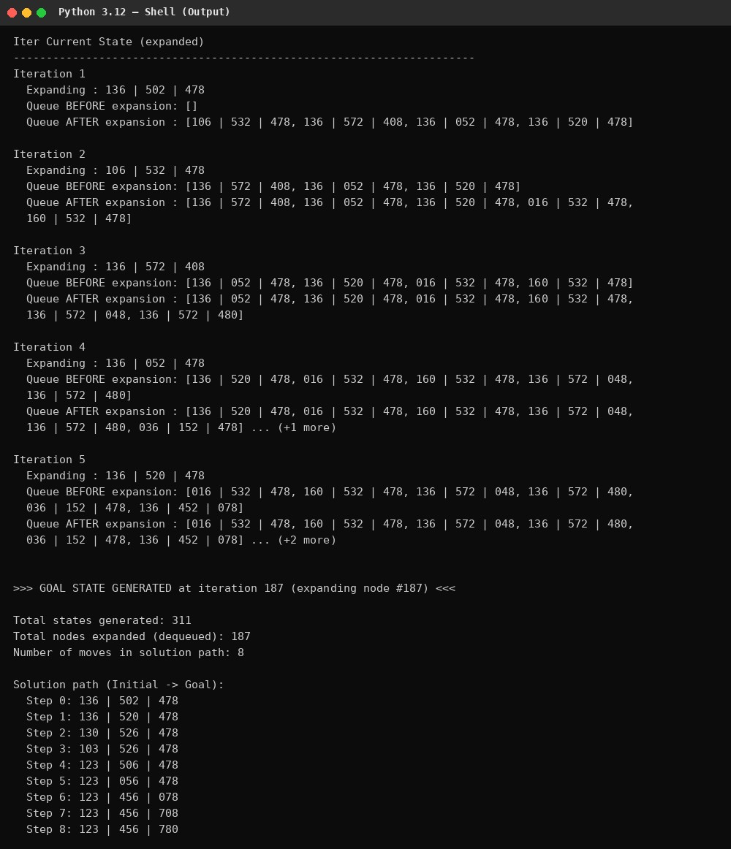

Answers

- Node expanded each iteration: the program prints "Expanding: <state>" for every iteration (1 through 187); the goal state was generated (as a child of the node expanded at iteration 187) rather than expanded itself, since BFS checks each newly generated child against the goal immediately.
- Total states generated: 311 (this counts every distinct board configuration produced during the search, including the goal state).
- Complete solution path from initial to goal state (8 moves):
1 3 6 / 5 0 2 / 4 7 8 → 1 3 6 / 5 2 0 / 4 7 8 → 1 3 0 / 5 2 6 / 4 7 8 → 1 0 3
/ 5 2 6 / 4 7 8 → 1 2 3 / 5 0 6 / 4 7 8 → 1 2 3 / 0 5 6 / 4 7 8 → 1 2 3 / 4 5 6 / 0 7 8 → 1 2 3 / 4 5 6 / 7 0 8 → 1 2 3 / 4 5 6 / 7 8 0
- Why BFS always finds the shortest solution in an unweighted 8-puzzle: BFS explores the state space level by level — it fully expands every state at depth d (i.e., every board reachable in exactly d moves) before moving on to any state at depth d+1. Since every move (tile slide) has the same cost (1), the first time the goal state is generated it is guaranteed to be at the smallest possible depth, i.e. the fewest number of moves. This is the defining property of BFS on an unweighted graph: it explores in non-decreasing order of path length from the start, so the first path found to any node is a shortest path.

